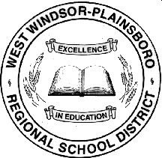
K-12 Guidance Curriculum Framework

The West Windsor-Plainsboro Regional School District Comprehensive K-12 Guidance curriculum is grounded in the American School Counselor Association (ASCA) National Model and Standards. Each grade level provides students a specific scope and sequence of Academic, Career and Personal/Social Development.
Student needs are met through individual and group counseling, classroom lessons and grade presentations.

Grade Level | Academic Development | Career Development | Personal/Social Development
K-5 | - Intervention & Referral Services / 504 Plans  - Study Skills  - Elementary School Transition | - Career Awareness | - Character Development  - Communication Skills  - Conflict Resolution  - Understanding Feelings  - Friendship / Social Skills  - Responsive Services
6-8 | - Intervention & Referral Services / 504 Plans  - Academic Integrity  - Middle School Transition  - Stress Management  - Study Skills | - Career Exploration | - Conflict Resolution  - Family Dynamics  - Peer Relations  - Responsive Services
9-12 | - Intervention & Referral Services / 504 Plans  - High School Transition  - College & Career Planning | - Career Exploration  - Post-Secondary Planning | - Responsive Services  - Student Support Groups: Anger Management, At-Risk, Bereavement, Divorce, ESL, Minority, Social Skills.

